**DAILY ONLINE ACTIVITIES SUMMARY**

|  |  |  |  |  |  |  |  |
| --- | --- | --- | --- | --- | --- | --- | --- |
| **Date:** | **09-06-2020** | | | | **Name:** | **Varsha H Shetty** | |
| **Sem & Sec** | **8th sem B sec** | | | | **USN:** | **4AL16CS117** | |
| **Online Test Summary** | | | | | | | |
| **Subject** | | **BDA** | | | | | |
| **Max. Marks** | | **30** | | **Score** | | **25** | |
| **Certification Course Summary** | | | | | | | |
| **Course** | **Introduction to AWS iot** | | | | | | |
| **Certificate Provider** | | | **AWS training and certification** | **Duration** | | | **10 mins** |
| **Coding Challenges** | | | | | | | |
| **Problem Statement-** : Function to print binary number using recursion | | | | | | | |
| **Status: completed** | | | | | | | |
| **Uploaded the report in Github** | | | | **yes** | | | |
| **If yes Repository name** | | | | **Varsha-Shetty** | | | |
| **Uploaded the report in slack** | | | | **yes** | | | |

O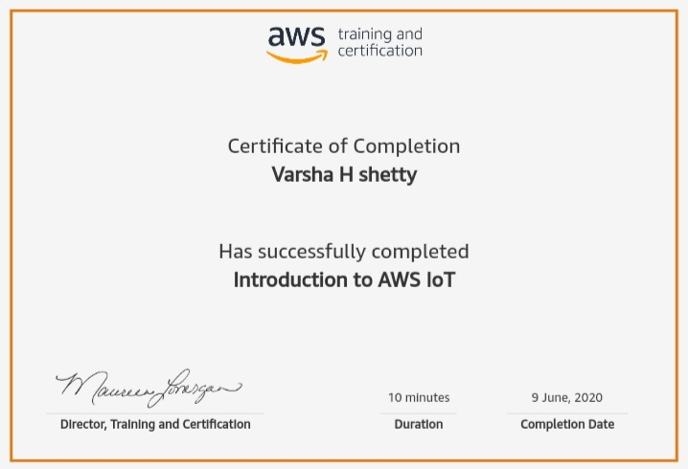nline Test Details: (Attach the snapshot and briefly write the report for the same)

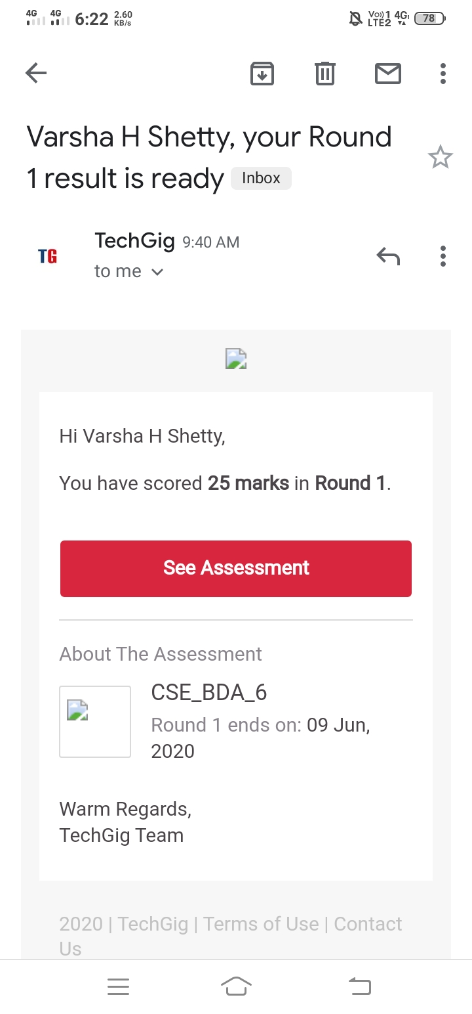

Certification Course Details: (Attach the snapshot and briefly write the report for the same)

Coding Challenges Details: (Attach the snapshot and briefly write the report for the same)

Coding was given and it was uploaded for github and slack

Function to print binary number using recursion

def convertToBinary(n):

if n > 1:

convertToBinary(n//2)

print(n % 2,end = '')

dec = 34

convertToBinary(dec)

print()